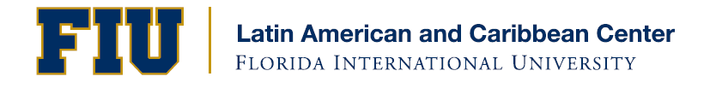
LACC/MDCPS Teacher Training Workshop: “The US and Cuba after D17: A Closer Look”

Florida International University
Modesto Maidique Campus, MARC Building, International Pavilion
Wednesday, September 23, 2015
8:30am-3:30pm

8:30am Registration

9:00am-9:10am Welcome
Liesl Picard, Associate Director, LACC, FIU
Bob Brazofsky, Executive Director, Department of Social Sciences, Miami Dade County Public Schools

9:10am-10:30am Session 1
A Change in Cuba Policy: Who, What, When, Where, Why & HOW?
Frank Mora, PhD, Director, LACC & Professor, Department of Politics & International Relations, FIU

10:30am-10:45am Break

10:45am-11:45am Session 2
D17 as a Watershed Moment: Forward-Looking or a Long-Time Coming?
Hugh Gladwin, PhD, Associate Professor, Department of Global & Sociocultural Studies, FIU

11:45am-12:45pm Lunch On Your Own

12:45pm-1:30pm Special Session
A Front Row Seat: Personal Reflections from the Re-Opening of the US Embassy in Havana
Marifeli Pérez-Stable, PhD, Professor, Department of Global & Sociocultural Studies, FIU

1:30pm-2:45pm Session 3
A Closer Look at Re-Connecting: Easier Said than Done?
Jorge Duany, PhD, Director, Cuban Research Institute & Professor, Department of Global & Sociocultural Studies, FIU

2:45pm-3:30pm Session 4
Next Steps for Hispanic Heritage Advocates at School-Sites
Bob Brazofsky, Executive Director, Department of Social Sciences
Miami Dade County Public Schools

3:30pm Evaluations

Presented by the Kimberly Green Latin American and Caribbean Center at Florida International University in partnership with the FIU Cuban Research Institute, Miami-Dade County Public Schools and the Florida Task Force for Hispanic Studies

Take Advantage of FIU Libraries’ Public Access Benefits!
- Over 100,000 books, journals, films & other special materials pertaining to Latin America & the Caribbean
- Materials available in Spanish, Portuguese, Haitian Creole & other regional languages
- Online databases & e-journals available for public use on campus
- Digital Library of the Caribbean (dLOC) freely available at www.dloc.com
- Latin American & Caribbean Information Services Librarian offers individualized reference services by appointment (Gayle Williams, gayle.williams@fiu.edu)
- Go to http://libguides.fiu.edu/lacguide for description of LAC holdings and resources
Modesto A. Maidique Campus, DM 353 ● Miami, Florida 33199
Telephone 305-348-2894 ● Fax 305-348-3593 ● http://lacc.fiu.edu

