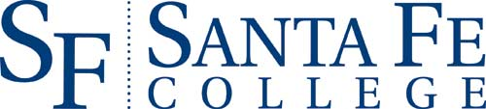

2nd Annual FIU/SF Faculty Seminar
U.S. - Latin America Relations
Under a Trump Presidency

Friday, March 17, 2017
Santa Fe College
Building S, Room 29
Gainesville, FL 32606

12:00-12:45pm Registration and Lunch

12:45pm Welcome and Introduction
Dr. Vilma Fuentes, Assistant Vice President of Academic Affairs, Santa Fe College (SF)
Dr. Frank Mora, Director, Kimberly Green Latin American and Caribbean Center (LACC), FIU

1:00-2:00pm Immigration and Security
Dr. Alan Beck or Dr. David Price, Professor of Political Science, SF
Dr. Frank Mora, Director, Kimberly Green Latin American and Caribbean Center (LACC), FIU

2:15pm-3:15pm U.S. Manufacturing & International Trade: Risks and Opportunities
Dr. Jake Searcy, Professor, Department of Economics, SF
Dr. Eduardo Gamarra, Professor, Department of Politics and International Relations, FIU (via SKYPE)

3:30pm-4:30pm The Future of US-Cuba Relations
Dr. Jorge Duany, Director, Cuban Research Institute, FIU
Dr. Vilma Fuentes, Assistant Vice President of Academic Affairs, SF

4:30-5:00pm Closing Remarks
Dr. Vilma Fuentes, Assistant Vice President of Academic Affairs, SF
Dr. Frank Mora, Director, Kimberly Green Latin American and Caribbean Center (LACC), FIU

Made possible with support from LACC’s U.S. Department of Education Title VI NRC Grant.

